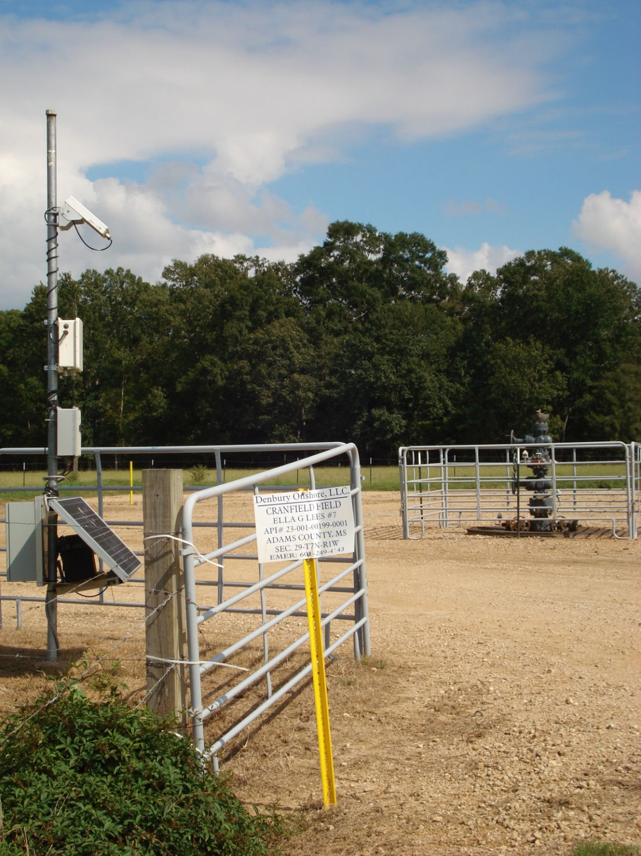
Figure 1. The SECARB Phase II Ella G. Lees #7 dedicated observation well at Cranfield in the distance, with satellite uplink equipment in the foreground. Photo taken on September 15, 2009, by Sams (SSEB).

Filename:1.jpg

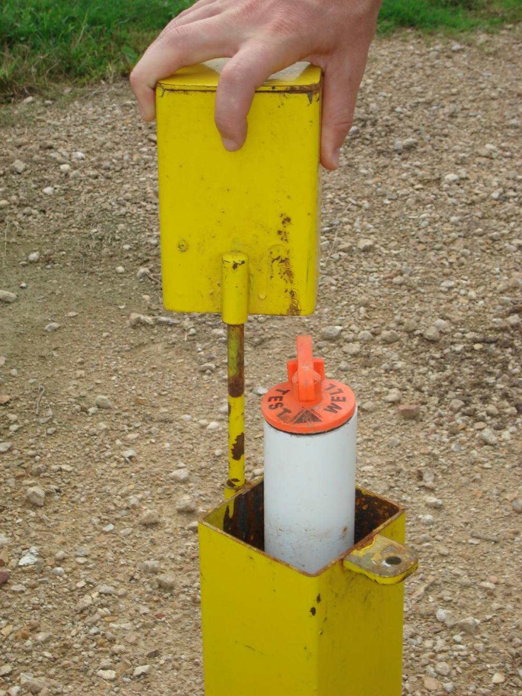
Figure 2. A SECARB Phase II groundwater test well on the Ella G. Lees #7 dedicated observation well pad at Cranfield. Photo taken September 15, 2009, by Sams (SSEB).

Filename: 2.jpg
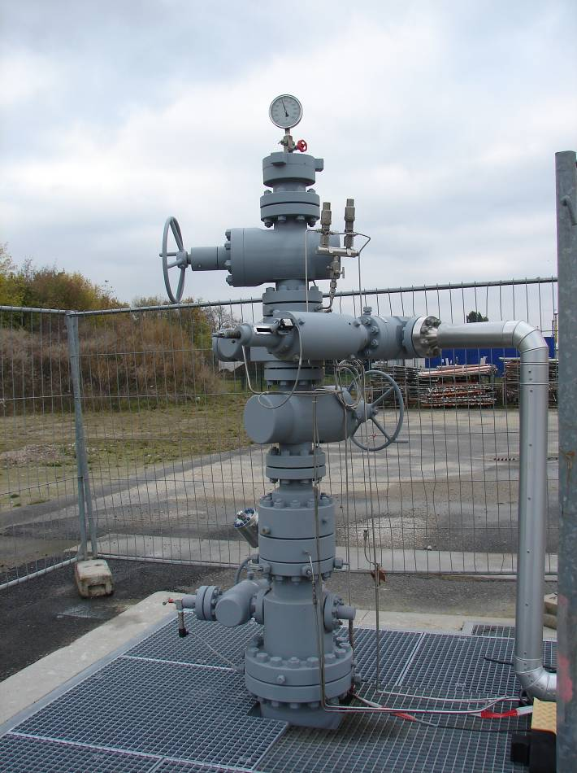
Figure 3. Ketzin injection experiment injection well.

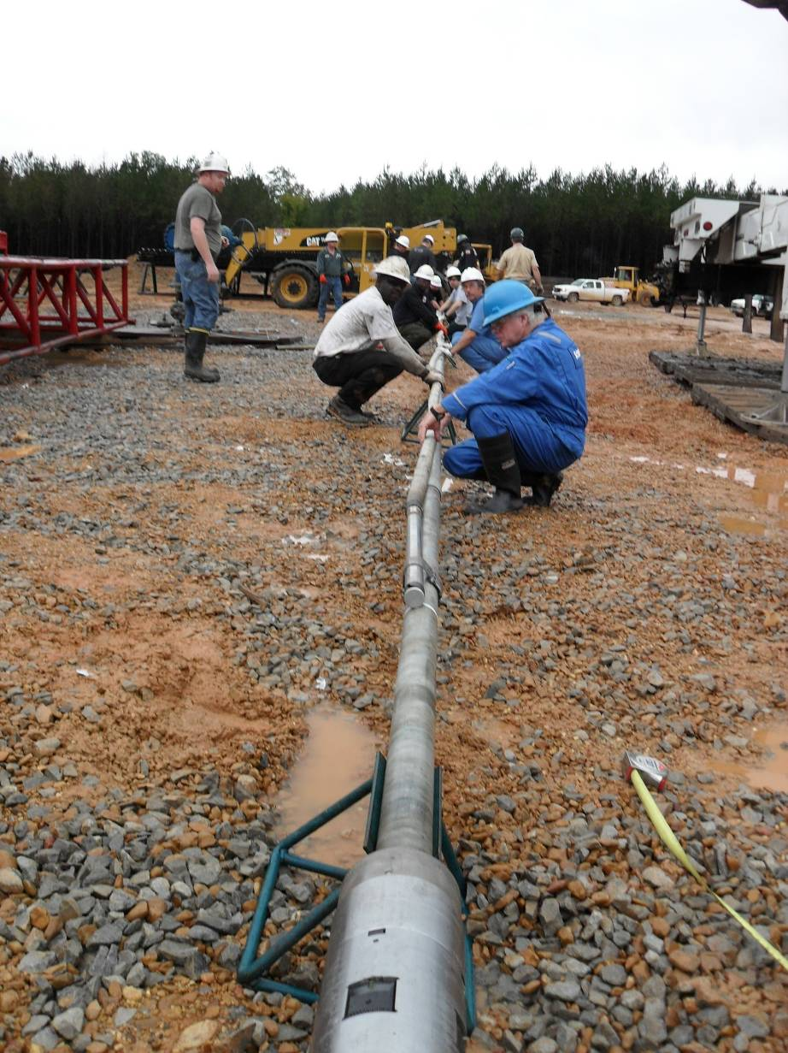
Figure 4. Packer and lower geophone assembly laid out for assembly.

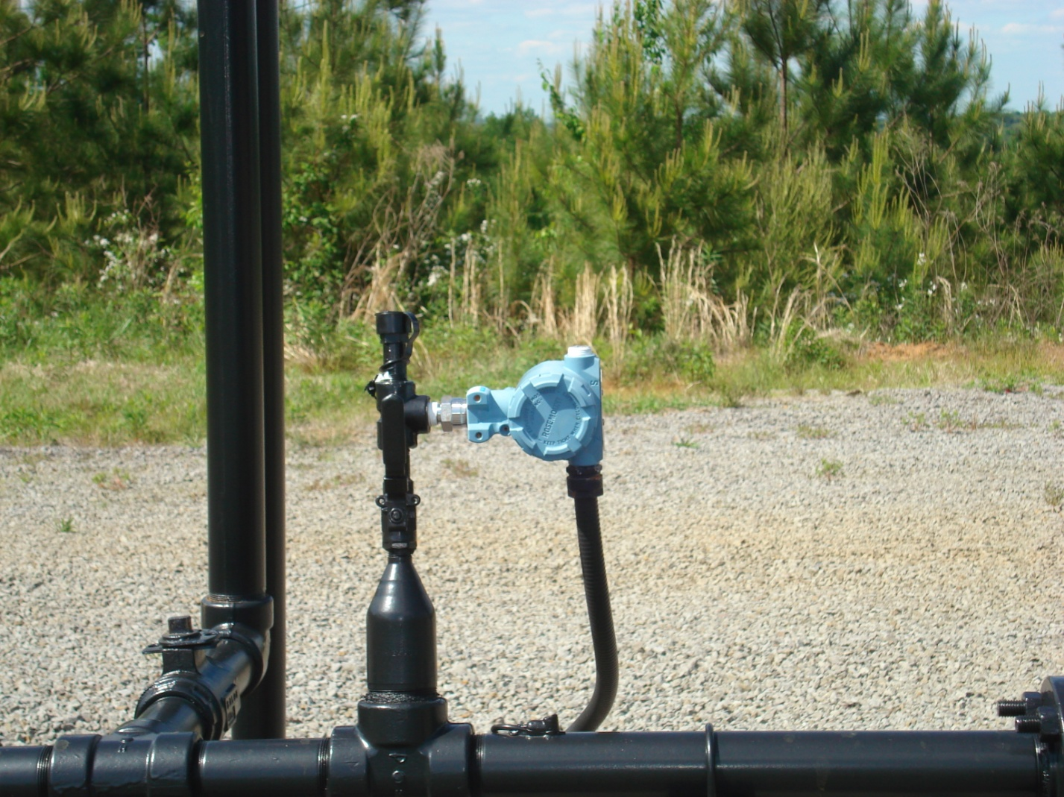
Figure 5. Gas sampling valve at the SECARB Phase II Black Warrior Basin Coal Seam project injection site near Tuscaloosa, Alabama. Photo by K. Sams, SSEB (April 28,2010).

Filename: 5.jpg
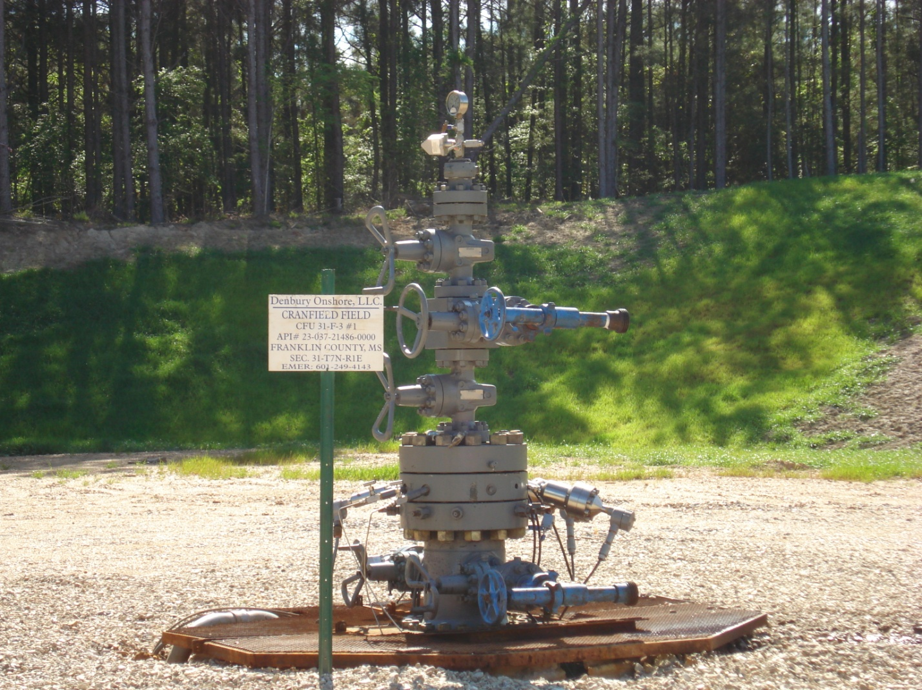
Figure 6. Monitoring well (CFU 31-F3) at the SECARB Phase III Early Test Detailed Area of Study at Cranfield. Photo by K. Sams, SSEB (April 10, 2010).

Filename: 6.jpg
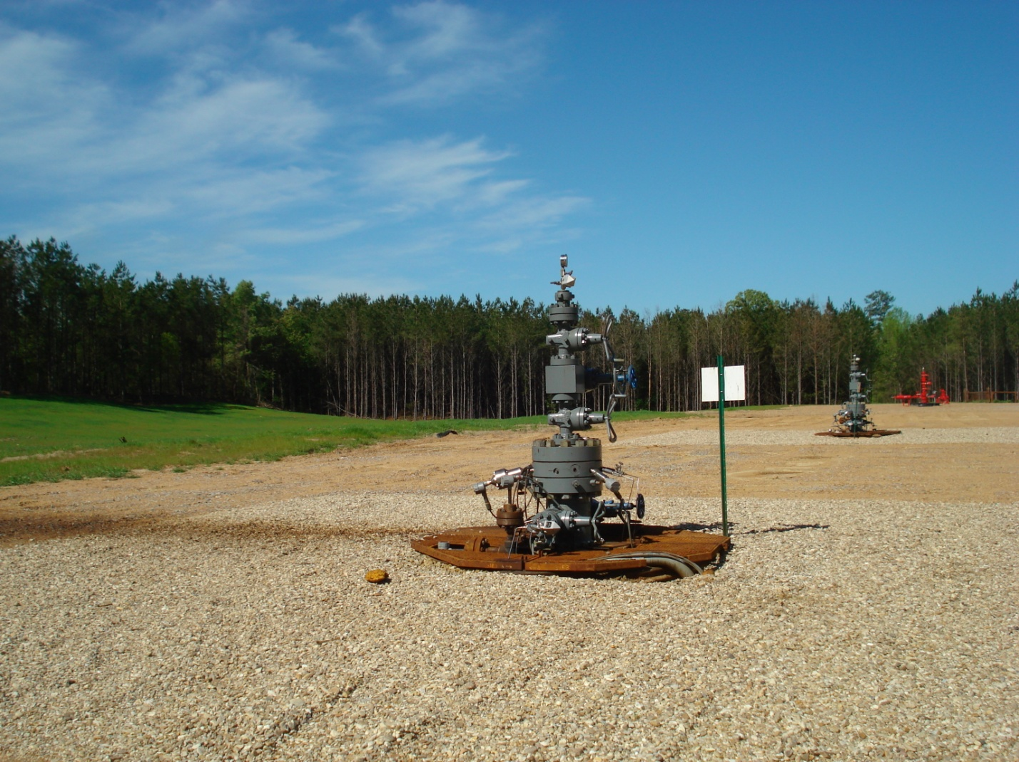
Figure 7. Two observation wells (grey) at the SECARB Phase III Early Test Detailed Area of Study monitor the CO₂ from the updip injection well (red) in the background. Photo by K. Sams, SSEB (April 10, 2010).

Filename: 7.jpg

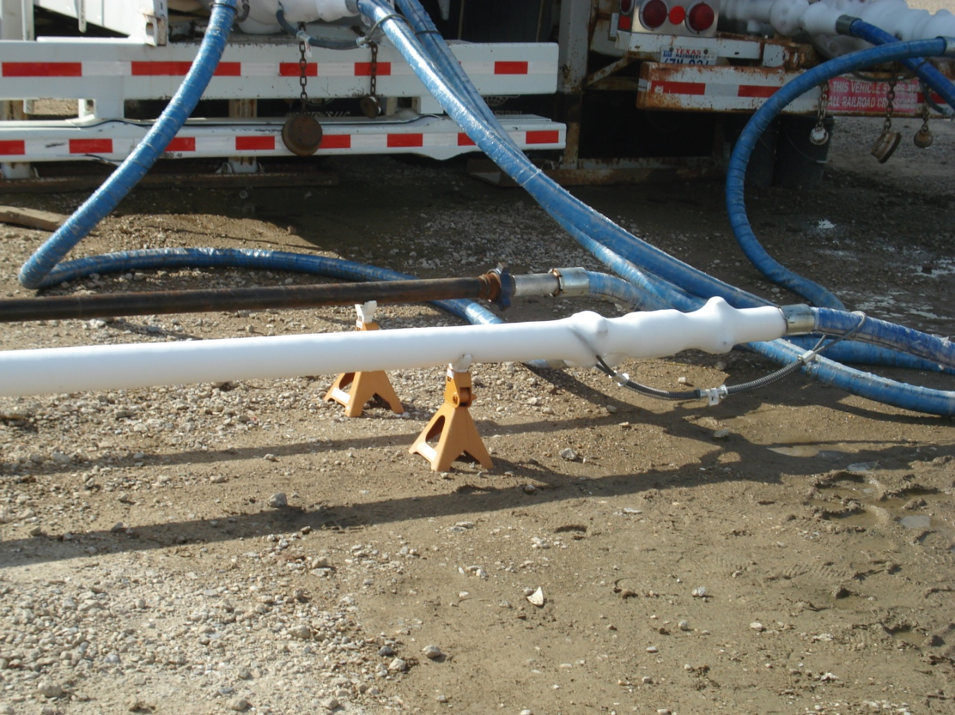
Figure 8. The CO₂ line from the storage tank to the injection well at the SECARB Phase II Mississippi Test Site in Escatawpa. Photo by K. Sams, SSEB (October 15, 2008).

Filename: 8.jpg

